# Learn to Ride

High-quality **Western and English riding** lessons, focusing on safety and including instruction on horse care, saddling a horse, and other aspects of horsemanship.

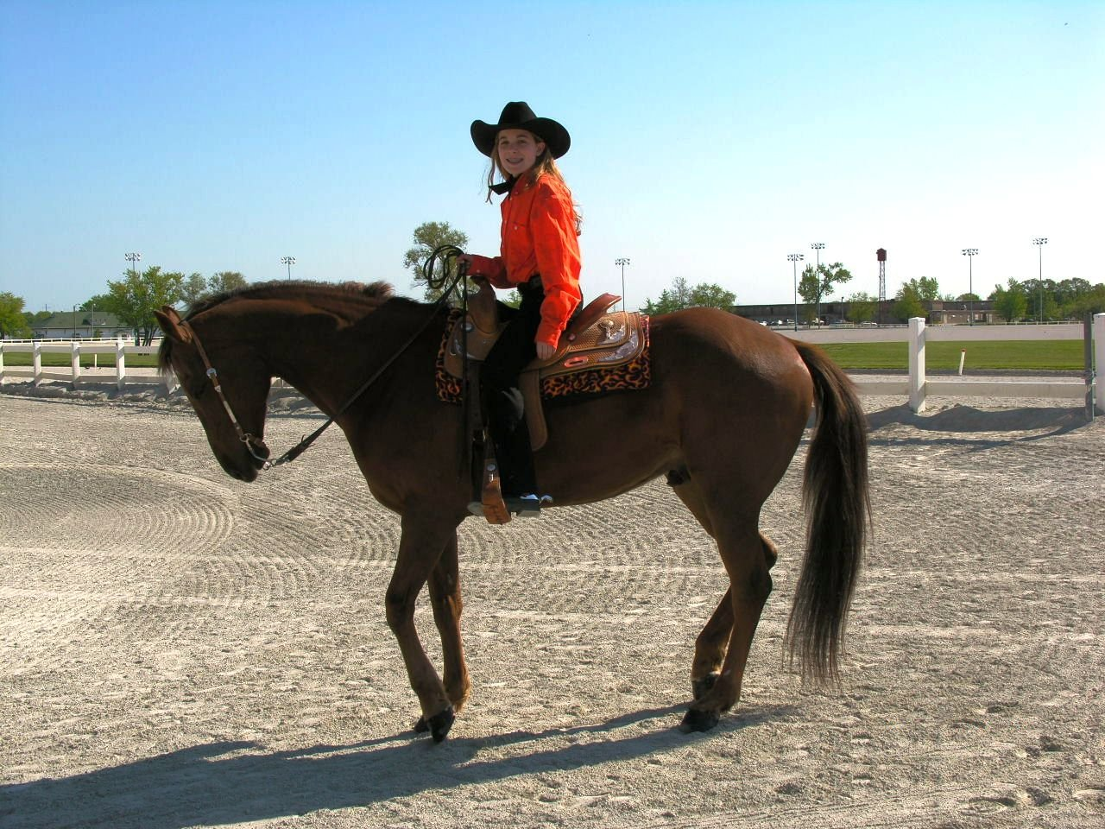

* Novice to advanced instructor for children and adults
* Indoor and outdoor arenas
* $40 per hour for private lessons; $25 for group lessons

## *Call Tri Valley Stables at 555-2030 today!*